**ESBPII - LAB2**

1. Log in to the Amazon account and S3 console management page

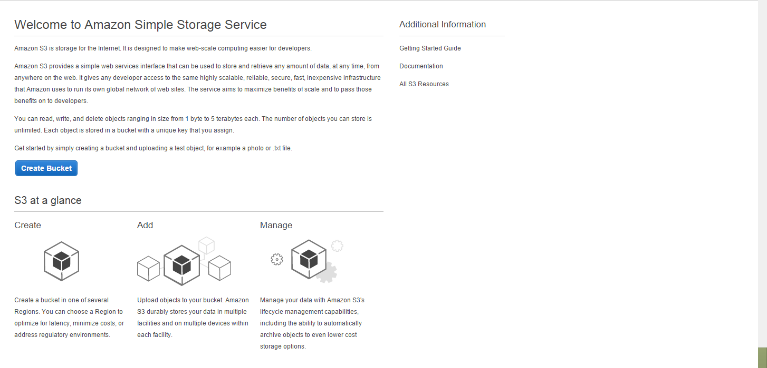

1. Press on the Create Bucket button in the page to create a bucket

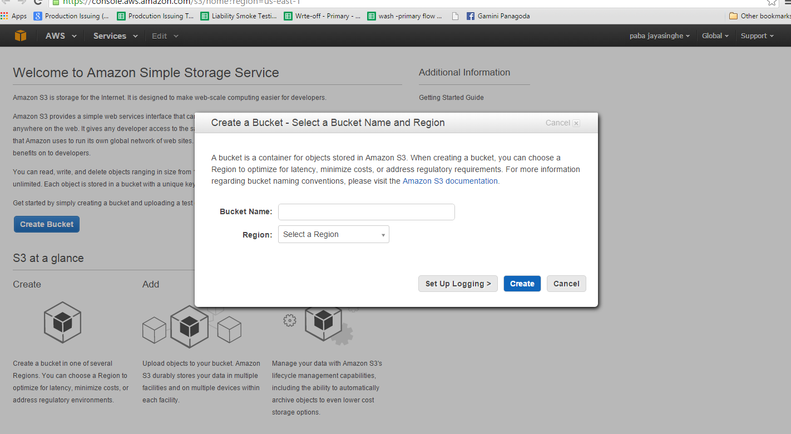

1. Give a name to Bucket , Bucket name should be unique around the Amazon and give the region as well and set permissions

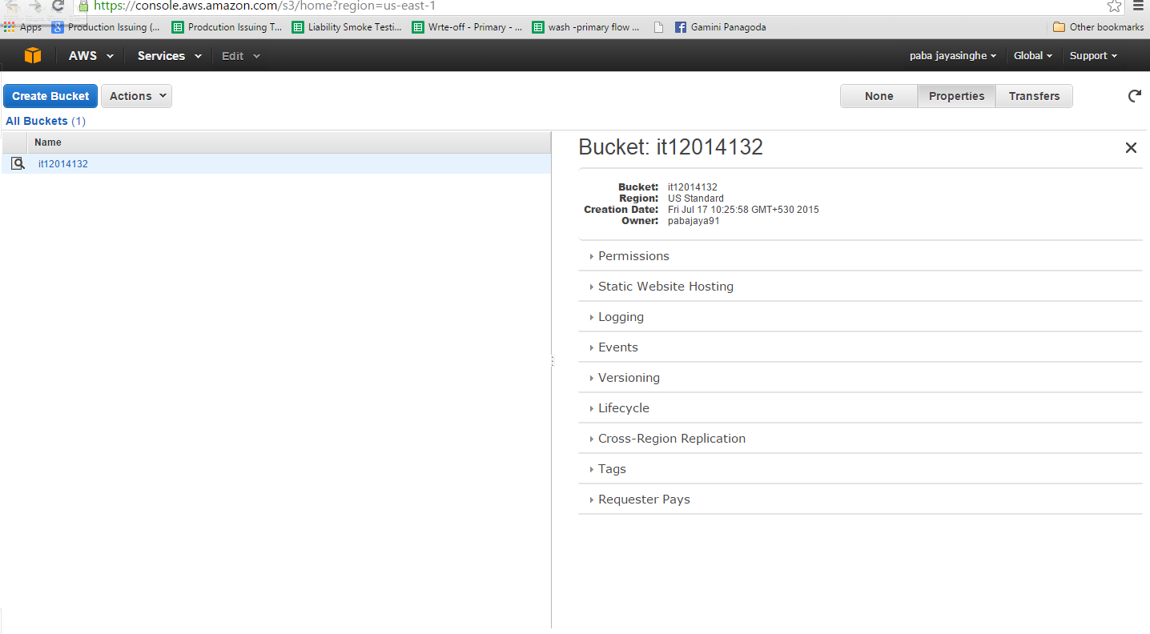

1. Create a folder inside a bucket right click on the Bucket and then press on the Create folder button and create an new folder and name

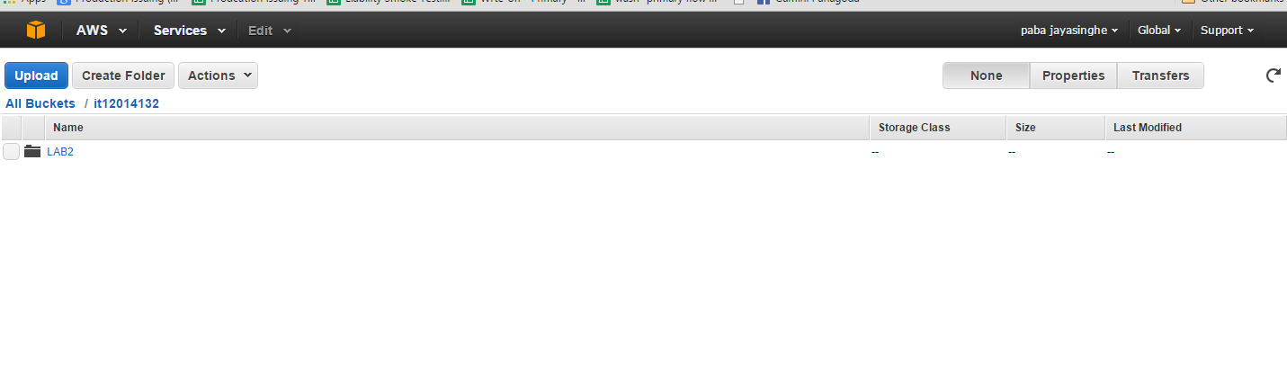

5. Right click on the newly created folder and press open to open the newly create file

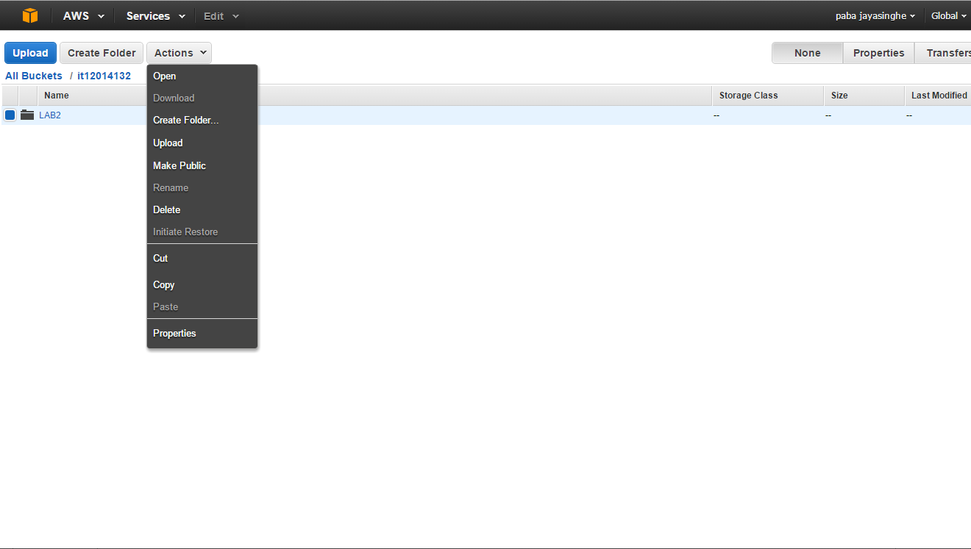

1. Press Upload button in the left corner and a pop up will appear

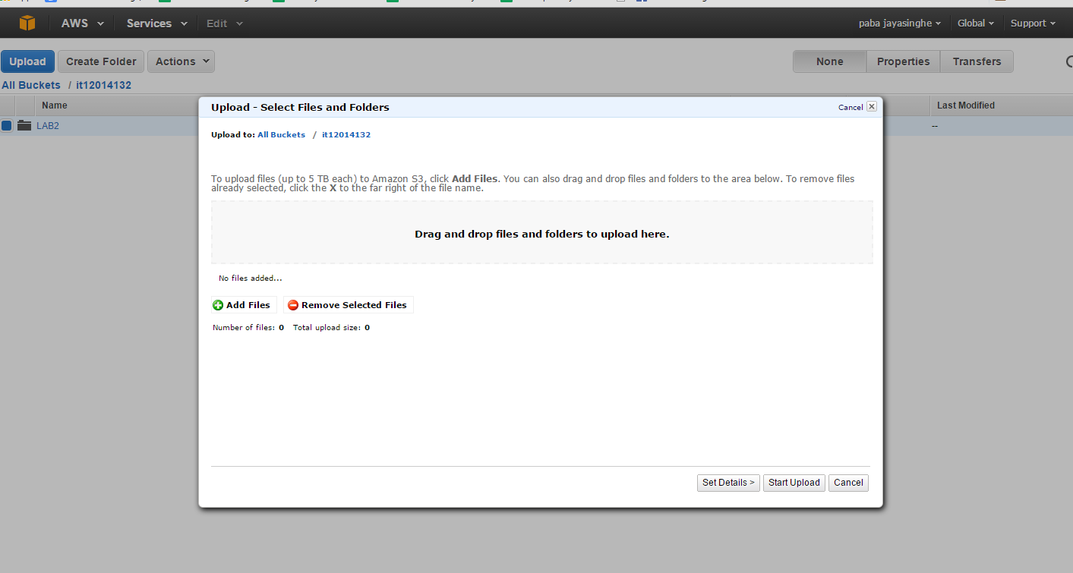

1. Browse for the file and upload 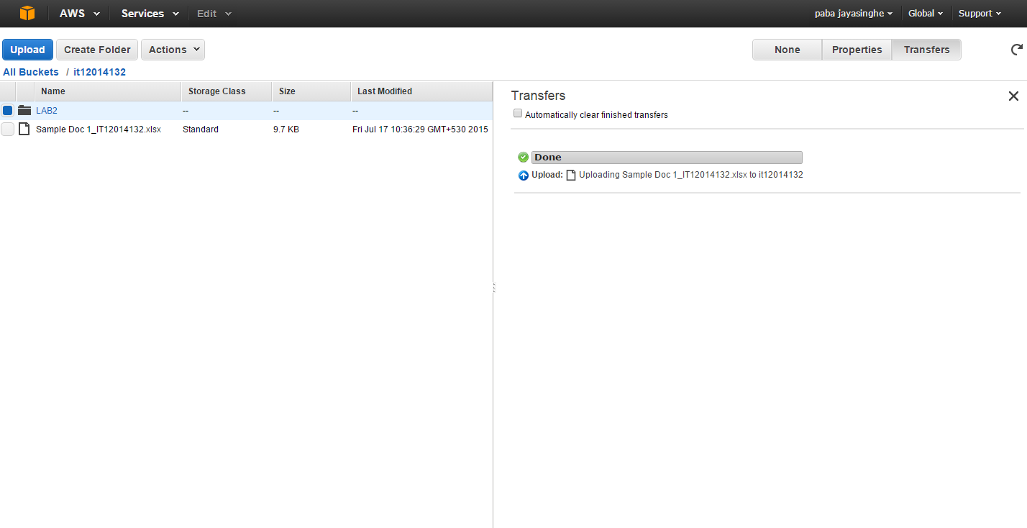
2. Like Wise can create multiple file inside this bucket

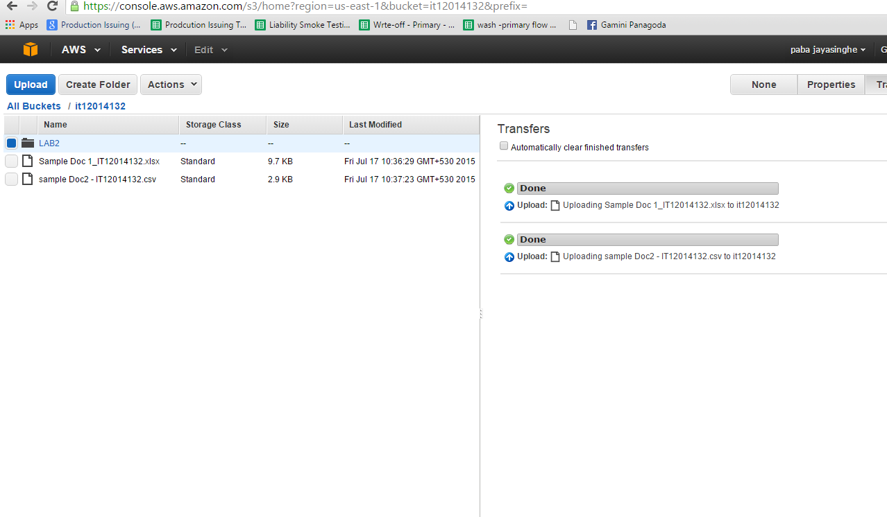

1. If you want to download the create object right click and then press the download button

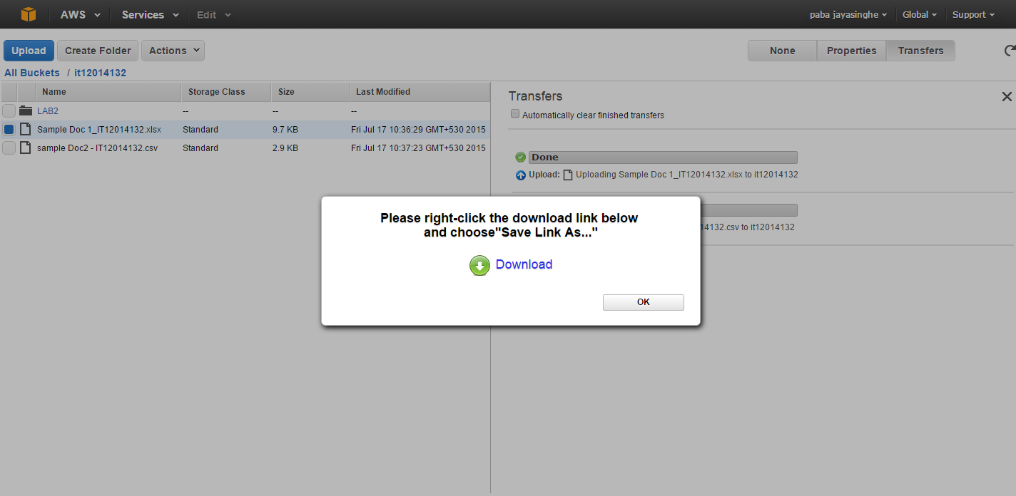

1. If you want to copy the document to another folder right click on the document and then copy after that select the new folder and paste it

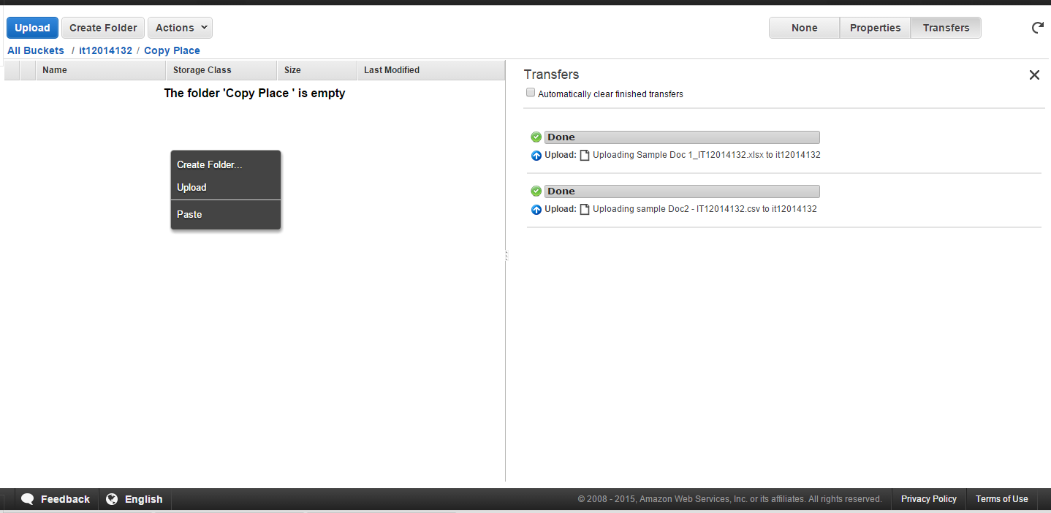

1. After Copying file it will show the progress

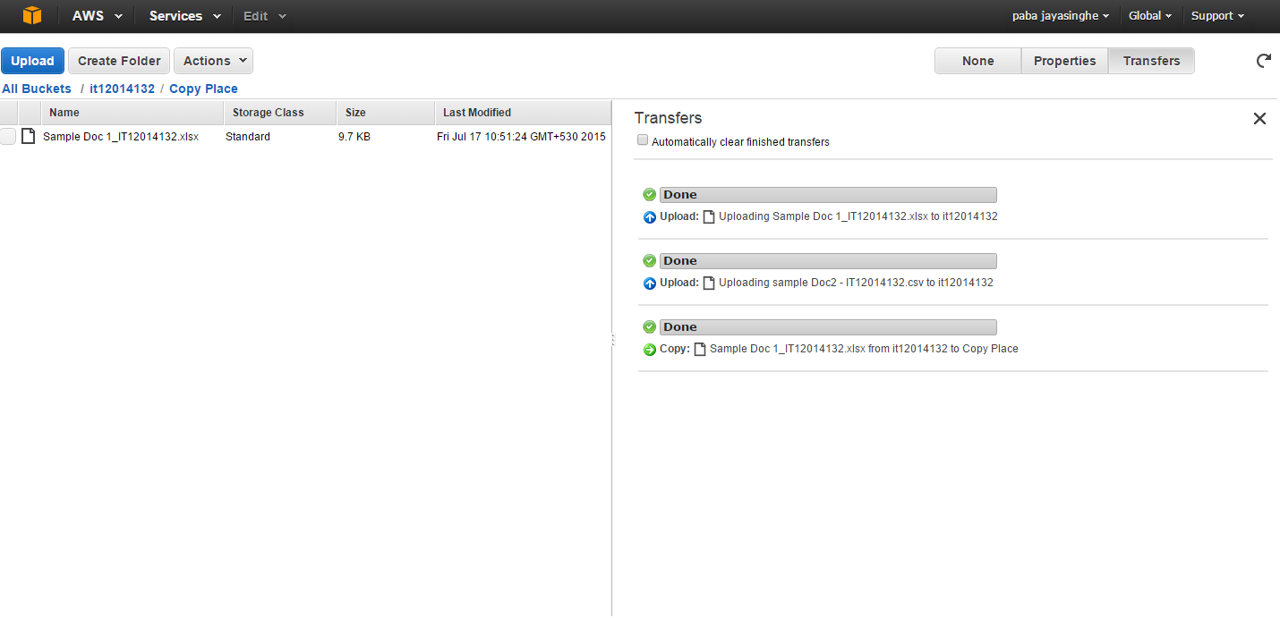

1. In order to delete object right click on it and press delete

